**IoT-Driven Robotic Arm Design and Development Using Arduino**

Dr. A.V.Sriharsha1, K.Mallikarjuna Reddy2, C.Naveen2, G.Steven2, T.Kushal Kumar2

[avsreeharsha@gmail.com](mailto:avsreeharsha@gmail.com,)[1](mailto:avsreeharsha@gmail.com,)[,](mailto:avsreeharsha@gmail.com,) [mallikarjunareddykanala2003@gmail.com](mailto:mallikarjunareddykanala2003@gmail.com,)[2](mailto:mallikarjunareddykanala2003@gmail.com,)[,](mailto:mallikarjunareddykanala2003@gmail.com,) [naveenchatta1@gmail.com](mailto:naveenchatta1@gmail.com,)[2](mailto:naveenchatta1@gmail.com,)[,](mailto:naveenchatta1@gmail.com,) [stev5858@gmail.com](mailto:stev5858@gmail.com,)[2](mailto:stev5858@gmail.com,)[,](mailto:stev5858@gmail.com,) thallakushalkumar2@gmail.com2

1 Mohan Babu University, Tirupati, India.

2 Sree Vidyanikethan Engineering College, Dept.of Information Technology, Tirupati, India.

**Abstract:**This paper introduces the creation of a robotic arm managed by an Arduino system arm designed for precision tasks in both medical and industrial applications, emphasizing its utility in pick-and-place operations. Leveraging Arduino UNO and potentiometer technologies, the robotic arm achieves multi-directional movement via servo motors, allowing for precise control essential in delicate settings. In the healthcare field, it could automate tasks such as pharmaceutical dispensing, laboratory sample handling, and sterile instrument organization. By handling these repetitive yet crucial tasks, the robot helps reduce human error, maintain sterile conditions, and enhance operational efficiency in hospitals and laboratories.In industrial contexts, this pick-and-place robot streamlines assembly and packaging processes, making it valuable for sectors like electronics, automotive manufacturing, and logistics. The Arduino-based control system enables cost-effective automation, especially in resource-constrained environments, offering a viable alternative to high-end robotics systems such as the Da Vinci Surgical Platform and Mako Robotic-Arm Assisted Procedure

**Keywords:**Robotic Arm, Potentiometric, Servo Motor, Degrees of Freedom, Programming Language, Translational Motion, Rotational Motion, Hand Gestures, Machine Tool, Gesture Recognition, Parallel Use, Human Arm, Plastic Pieces, Spot Welding.

1. METHODS AND MATERIALS

###### 

Fig 1.1 arduino UNO microcontroller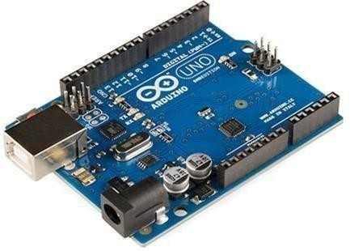

**Arduino UNO:**This microcontroller serves as the primary control unit, programmed to direct and control the servo motors responsible for the robotic arm’s movement. The Arduino UNO is compact, user-friendly, and open-source, making it an ideal choice for hobbyists and researchers. It features an ATmega328 microcontroller with 2 KB of RAM, 32 KB of flash storage, and functions at a 16 MHz clock frequency, allowing for real-time processing of commands.

**Fig 1.2 CIRCUIT DIAGRAM FOR SERVO ROBOTIC ARM**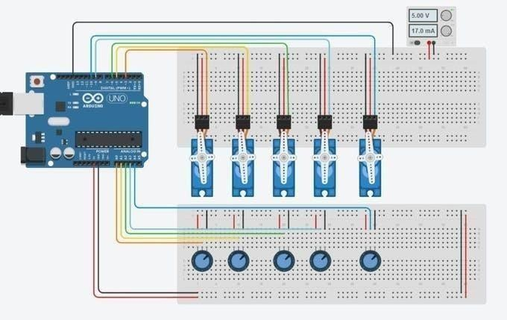

**Servo Motors:** Servo motors are critical for managing each articulation of the robotic arm, enabling multi-directional movement. Each servo motor includes a control circuit and a potentiometer, which allows precise control over the position and movement. For pick-and-place tasks, several servos (DC servos are preferred) are needed to control the robotic arm’s base, shoulder, elbow, and gripper. These servos typically require 4.8 to 6V and can be powered by the same supply as the Arduino.

**Potentiometer s:** Potentiometer s are used as input devices that allow the operator to adjust servo motor positions precisely. By reading the analog signal from potentiometer s, the Arduino translates these signals into digital commands that control the motors position, ensuring smooth and accurate movements.

**RF Transmitter and Receiver Modules (433 MHz):** To allow for wireless control, we use RF modules to communicate between the Arduino board and a remote controller. The RF module facilitates communication even with physical obstructions and operates within a voltage range of 3V to 12V.

**Fig 1.3 RF Transmitter and receiver Block Diagram**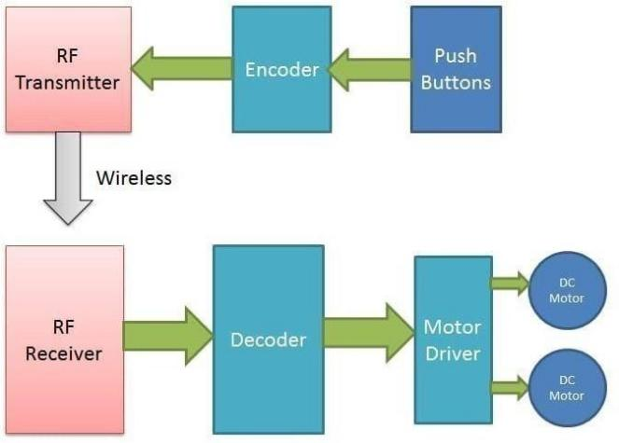

#### **ROBOT ARM MECHANIC**

**2.1 General Features of Robotic Arm Mechanics**

Kinematics in robotics emphasizes analyzing the movement of robot parts. Robotic arm segments can pivot or translate relative to a defined coordinate system.The Denavit-Hartenberg (DH) convention provides a standardized method to connect the robot’s endpoint with the overall movement of its links. Joint coordinates, determined by the angular and linear displacements between links, are known as limb variables. The transformations that represent these rotations and translations of each link, referred to as matrices A, are successively multiplied to determine the ultimate position and orientation of the robot’s end-effector in forward kinematics. Conversely, if the endpoint coordinates are specified, limb variables can be determined using inverse kinematics. The details of forward and inverse kinematics are discussed in the following section. Constructing the general transformation matrix, such as the Jacobian for standard robots, can be complex.A vector in an n-dimensional space can be represented as an n+1-dimensional vector in homogeneous coordinates. The matrix below shows a 4×4 format for a position vector in homogeneous coordinates between reference frames.

$RT_{H}$*= $\left[\begin{matrix}x_{x} & y_{x} & z_{x} & p_{x} \\ x_{y} & y_{y} & z_{y} & p_{y} \\ x_{z} & y_{z} & z_{z} & p_{z} \\ 0 & 0 & 0 & 1\end{matrix}\right]$*

If any of the 3 coordinate axes can rotate, there are 3 rotational transformations corresponding to rotations around the x, y, and z-axes by an angle 𝑞. The following matrix represents the rotation around the x-axis:

*Rot(x,θ)= $\left[\begin{matrix}1 & 0 & 0 & 0 \\ 0 & cos(θ) & −sin(θ) & 0 \\ 0 & sin(θ) & cos(θ) & 0 \\ 0 & 0 & 0 & 1\end{matrix}\right]$*

The matrices representing rotations only around the y and z-axes can be written as follows in a similar manner.

*Rot(y,θ)= $\left[\begin{matrix}cos(θ) & 0 & sin(θ) & 0 \\ 0 & 1 & 0 & 0 \\ −sin(θ) & 0 & cos(θ) & 0 \\ 0 & 0 & 0 & 1\end{matrix}\right]$*

*Rot(z,θ)= $\left[\begin{matrix}cos(θ) & −sin(θ) & 0 & 0 \\ sin(θ) & cos(θ) & 0 & 0 \\ 0 & 0 & 1 & 0 \\ 0 & 0 & 0 & 1\end{matrix}\right]$*

The elements of the transformation matrix can be derived through the arithmetic multiplication of pure rotation and displacement matrices. This can be achieved by a series of rotations about the axes of the fixed reference frame when the orientation is needed in relation to the reference frame of the Cartesian space endpoint. While there are various methods for this, one of the most widely recognized is the "roll-pitch-yaw" transformation, which involves three rotations: the first around the x-axis, followed by the y-axis, and finally around the z-axis.

***RPY(ɸ,θ,Ѱ)=Rot(z,ɸ)Rot(y,θ)Rot(x,Ѱ) $\left[\begin{matrix}C(∅)C(θ) & C(∅)S(θ)S(φ)−S(∅)C(φ) & C(∅)S(θ)S(φ)−S(∅)C(φ) & 0 \\ C(∅)C(θ) & C(∅)S(θ)S(φ)−S(∅)C(φ) & C(∅)S(θ)S(φ)−S(∅)C(φ) & 0 \\ −S(∅) & C(∅)C(θ) & C(∅)C(θ) & 0 \\ 0 & 0 & 0 & 1\end{matrix}\right]$***

Kinematics in robotics is the science of motion investigation. The robot examines the positions of the limb limbs, the relationships between velocities and accelerations, ignoring forces and other factors that affect movement.

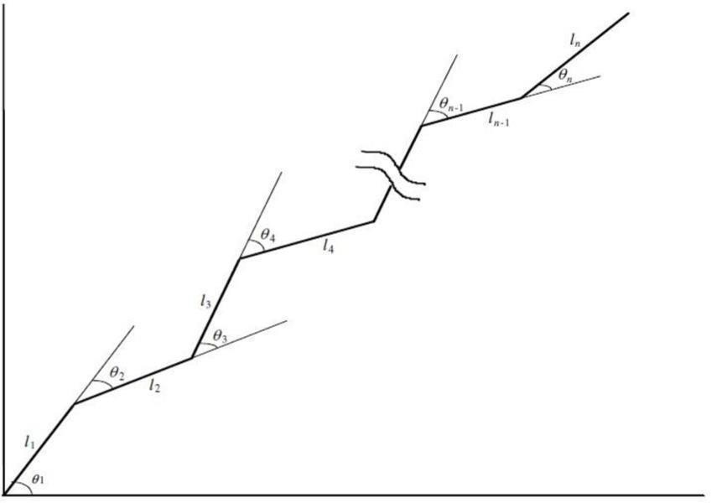

**Fig 2.1 A serial robotic arm with aligned joints is displaying relative angles**

When the location and alignment of a limb, or the relative alignment between a limb and the endpoint, changes in a serial-chain robot arm (as illustrated in the figure), it is often necessary to calculate the location and alignment of the endpoint in relation to the origin reference frame.By assigning a coordinate frame to each moving segment, The transformation between each pair of segments can be expressed by a homogeneous transformation matrix, denoted as matrix A. For example, the first segment is attached to the base frame. through matrix A1, symbolized as ${}_{1}^{0}A$. The transformation matrix $R_{TH}$ representing the endpoint's position and orientation relative to the base frame can be determined by sequentially multiplying the matrices A, starting from $A_{1}$ ​ up to the matrix for the endpoint.

$R_{TH}$ = R $T_{1}$* 1T2 * (n-2)T(n-1) * (n-1)TH = 0A1 * 1A2 * ... * (n-2)A(n-1) * (n-1)An

In practical applications, knowing the endpoint's location and alignment relative to the base is crucial for tasks like object manipulation, assembly, or any scenario where precise movement and positioning are required. This transformation process allows us to mathematically calculate the endpoint’s configuration based on the known parameters of each limb (like length and angle).

By using this equation, you can determine the exact spatial configuration of the robot arm’s endpoint, which is essential for programming the robot to reach specific positions and perform tasks accurately.

**Experimental verification of the pick-and-place 4R robotic arm**

The 4R Pick and Place robotic arm is verified using joint angles and parameters acquired through both software simulations and theoretical calculations. For experimental verification, the servo motors corresponding to each joint of the robotic manipulator are rotated to the final joint angles of θ₁ = 30°, θ₂ = 90°, θ₃ = 135°, and θ₄ = 0° to carry out the pick-up task. The servo motor motion is managed by an Arduino Uno, which is programmed to execute the necessary rotations, leading to the movement of the 4R robotic arm. to the designated grabbing position.The experimental findings are then contrasted with theoretical and simulated values and are found to be consistent. Therefore, the direct kinematic analysis of the 4R robotic arm for the grabbing position is successfully verified.

**Conclusion**

Robotic arms have significant potential for development across various fields. With robotic arms, numerous tasks become easier to accomplish, and the margin for error is greatly minimized. For instance, pharmacy-based robots for dispensing medication and a prototype robotic arm have already been designed. Moreover, enhancing the mobility of the robotic arm and incorporating a camera in the finger area with improved sensitivity allows it to be applied across a broad range of fields, from medical applications to control systems.In healthcare, such advanced robotic arms reduce the risk of infection transmission to patients and minimize human errors during surgical procedures. Although the robotic arm created in this project is a prototype, it has qualities that can be improved for more advanced robotic systems. Furthermore, the robotic arm industry, which has immense growth potential, is expected to maintain its relevance in the future.The project aims to design a robot arm with control over four axes, operated through an appropriate microcontroller and Bluetooth module, along with an Android application. The required theoretical and practical knowledge was gathered, and a strong foundation for the project was built. Throughout the design and development stages, extensive theoretical knowledge was translated into practice, ensuring the project aligns with its intended purpose.

References

1. Sanket S Unde, F.: Theoretical and experimental investigation on direct kinematic of pick and place 4R robotic arm using algebraic and software approach.Springer Journal 2(5), 99–110 (2024).
2. Navin Kumar Agrawal, Vinay Kumar Singh, Vinay Singh Parmar, vijay Kumar Sharma, Dipti Singh, Muskan Agrawal, Design and Development of IoT based Robotic Arm by using Arduino, Proceedings of the Fourth International Conference on Computing Methodologies and Communication (ICCMC 2020) IEEE Xplore Part Number:CFP20K25-ART; ISBN:978-1- 72814889-2
3. K. Rahul, Hifjur Raheman, Vikas Paradkar, Design and development of a 5R 2DOF parallel robot arm for handling paper pot seedlings in a vegetable transplanter, Computers and Electronics in Agriculture 166 (2019) 105014Author, F.: Contribution title. In: 9th International Proceedings on Proceedings, pp. 1–2. Publisher, Location (2010).
4. Shunli Xiao and Yangmin Li, Visual Servo Feedback Control of a Novel Large Working Range Micro Manipulation System for Microassembly, JOURNAL OF MICROELECTROMECHANICAL SYSTEMS, VOL. 23, NO. 1, FEBRUARY 2014
5. Shivam Sharma, Shashwat Sahai, Jaisal Joshi, Hema N, Stage-wise Development of a Remote Controlled Robotic Arm, 5th IEEE International Conference on Parallel, Distributed and Grid Computing(PDGC-2018), 20-22 Dec, 2018
6. S. A. Khan, T. Z. Anika, N. Sultana, F. Hossain, M. N. Uddin, Color Sorting Robotic Arm, 2019 International Conference on Robotics,Electrical and Signal Processing Techniques (ICREST)
7. Shunli Xiao and Yangmin Li, Visual Servo Feedback Control of a Novel Large Working Range Micro Manipulation System for Microassembly, JOURNAL OF MICROELECTROMECHANICAL SYSTEMS, VOL. 23, NO. 1, FEBRUARY 2014
8. Singh, A., Kanchan, R.P., Singh, S.: A review paper on analysis and simulation of kinematics of 3R robot with the help of roboanalyzer. Int. J. Eng. Res. Technol. (2016). <https://www.ijert.org/view-pdf/15097/a-review-paper-on-analysis-and-simulation-of-kinematics-of-3r-robot-with-the-help-of-roboanalyzer>
9. Kofinas, N., Orfanoudakis, E., Lagoudakis,M.G.: Complete analytical forward and inverse kinematics for the NAO humanoid robot.J. Intell. Robot. Syst. 77, 251–264 (2015)
10. Bharath, L.V.: Forward kinematics analysis of robot manipulator using different screw operators. Int. J. Robot. Autom. 3(2), 21–28(2018)
11. González-García, S., Rodríguez-Arce, J., Loreto-Gómez, G., et al.:Teaching forward kinematics in a robotics course using simulations: transfer to a real-world context using LEGO mindstorms™.Int. J. Interact. Des. Manuf. 14, 773–787 (2020)
12. He, R., Zhao, Y., Yang, S., Yang, S.: Kinematic-parameter identi-fication for serial-robot calibration based on POE formula. IEEE Trans. Robot. 26(3), 411–423 (2010)
13. Corke, P.I.: A simple and systematic approach to assigning Denavit–Hartenberg parameters.IEEE Trans. Robot. 23(3), 590–594(2007).